**Jeremiah Albright**

**CSC 174**

**Hw4**

**11/16/18**

1. Given R(C, D, E, F, G), and the following functional dependencies:

F 🡪 E

F 🡪 G

C 🡪 D

We decompose R into two relations R1(C, D) and R2(E, F, G, C). Does this decomposition have the lossless join property? Show your steps to achieve the answer.

(This one does not need to be typed.)

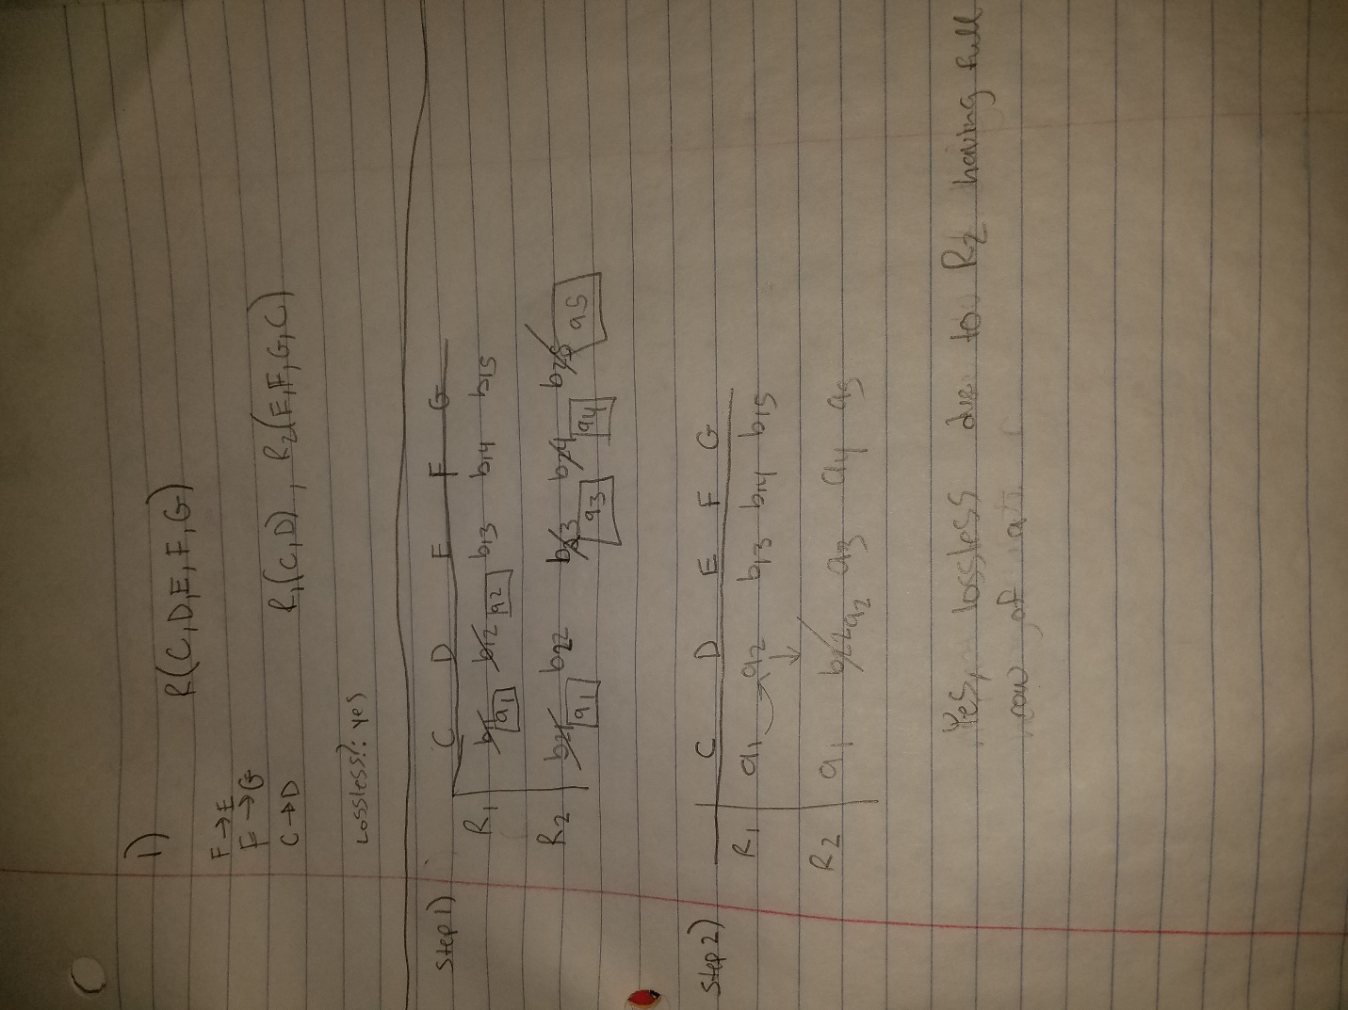

CORRECT

1. Given R(a,b,c,d,e,f,g) and the following functional dependencies:

Fd1: a 🡪 {b,c}

Fd2: d 🡪 {e,f}

Decompose R into 3rd normal form with both dependency preservation property and loss-less join property.

(This one must be typed)

Fd1: a 🡪 {b,c} already in minimal cover

Fd2: d🡪{e,f}

* R1(a,b,c)
* R2(d,e,f)

Find key algorithm

K := {a,b,c,d,e,f,g}

K-a={b,c,d,e,f,g}

{K-a}+ = {b,c,d,e,f,g} attribute a is a key

-tried K-b not key, K-c not key, K-d attribute d is a key , K-e not key, K-f not key

{K-g}+ ={a,b,c,d,e,f} attribute g is key

R3(a,d,g)

Result

R1(a,b,c)

R2(d,e,f)

R3(a,d,g)

1. Given R(x,y, c,z,e,f,g). There are two keys: (x,y) and z. Given the following functional dependency: F = { {x,y} 🡪 {c,z,e,f,g}, z 🡪 {x,y, c, e,f,g}, f🡪 x}. Decompose R into BCNF.

(This one must be typed)

1. D:= {R}
2. While(relation not in BCNF) do {

Fd1: is in BCNF; {x,y} 🡪 {c,z,e,f,g

Fd2: is in BCNF; z 🡪 {x,y, c, e,f,g}

Fd3: is NOT in BCNF; f🡪 x violates BCNF

Sup1(y,c,z,e,f,g)

Sup2(f,x)

}

Result

Sup1(y,c,z,e,f,g)

Sup2(f,x)